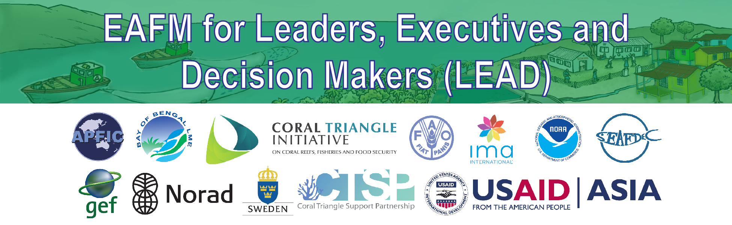
B3: Reference material
How many EAFM-type actions are you already doing and how are they linked?
PURPOSE
- To give leaders confidence that they are already doing some EAFM-type interventions/actions
- It shows how different actions relate to typical objectives of management
- It also helps to show how there are multiple objectives in fisheries and that some actions may contribute several outcomes.

HOW TO USE THIS DOCUMENT

This document is to be used in the LEAD one-day Executive course.
- Use the list to get leaders to identify the sorts of actions that are being taken under the three categories
- Note that the list does not show how these objectives or interactions often inter-relate and the linkages between them. This needs to be pointed out after the actions are identified
- So ask the question “Of these interventions, how many are linked at the fishery level?”
- Does one action give several outcomes?

TYPICAL OBJECTIVES AND ACTIONS

Objective | ACTIONS
Human well-being
Improving livelihoods and food security | Development of other alternative economic activities such as aquaculture for the relocation of fishing effort/communities
Improving livelihoods and food security | Compensation mechanisms during closed seasons or restricted gear periods
Improving livelihoods and food security | Fishers insurance schemes
Improving livelihoods and food security | Access to micro-finance/credit
Improving livelihoods and food security | Small-scale fisheries promotion
Improving livelihoods and food security | Securing affordable fish for national food security
Improving livelihoods and food security | Contributing to nutritional quality and sufficiency
Improving livelihoods and food security | Climate change related adaption actions
Improving income/market access | Promoting export income
Improving income/market access | Fish post harvest quality improvement (small-scale fisheries and commercial fisheries)
Improving income/market access | Hygienic fishing landing sites/ports programme
Improving income/market access | Fishery eco-labelling & certification
Providing decent employment | Improved safety at sea programmes
Providing decent employment | Minimum labour standards on board and inspection/accident reporting system
Providing decent employment | Fishing crew monitoring
Reducing operational costs | Facilitating migrant labour
Reducing operational costs | Fuel subsidies
Reducing fishery conflicts | Establishment of zoning systems (e.g. artisanal fishing zones)
Ecological well-being
Protecting or limiting impacts on habitats | Conservation and rehabilitation of the marine ecosystem through the establishment of closed areas and Marine Parks.
Protecting or limiting impacts on habitats | Reef, coastal habitat (e.g. nearshore zone, mangrove, delta, seagrass protection)
Protecting or limiting impacts on habitats | ICZM planning (integrating fisheries)
Protecting or limiting impacts on habitats | Sensitive ecosystem management plans (using ecosystem health indicators)
Protecting or limiting impacts on habitats | Sanctuaries/management areas for shark/hilsa/threatened species
Conservation & protection of biodiversity | Limiting/managing by-catch (ETP, juveniles commercial species, low value/trash fish)
Conservation & protection of biodiversity | Development & implementation of an NPOA Sharks/turtles
Conservation & protection of biodiversity | Grouper Management Plan, protection of spawning aggregations
Conservation & protection of biodiversity | Shark fishing ban
Managing impacts on fisheries resources for sustainability | Gear regulations to limit effort/impacts
Managing impacts on fisheries resources for sustainability | Development of zoning systems
Managing impacts on fisheries resources for sustainability | Seasonal closures
Managing fishing effort & capacity | Fishing vessel capacity reduction schemes
Managing fishing effort & capacity | Limit fishing effort through the issue of licenses for fishing gear and fishing vessels
Managing fishing effort & capacity | Fishing zoning systems, based on the type of fishing gear used, the tonnage of fishing vessels and the ownership
Managing fishing effort & capacity | Vessel fishing days schemes; fleet effort management schemes
Managing fishing effort & capacity | Removal of subsidy schemes
Governance
Improved vessel & flag-state controls | Vessel registration and licensing coordination between agencies
Improved vessel & flag-state controls | Installation of VMS
Improved vessel & flag-state controls | Fisher registration and ID card programmes
Combatting IUU fishing | Strengthening MCS capacity and implementation
Combatting IUU fishing | Improved MCS on industrial vessels (e.g. VMS systems)
Combatting IUU fishing | At sea patrols in IUU hotspots
Combatting IUU fishing | In-port inspections for compliance with management measures
Combatting IUU fishing | IUU reporting system
Combatting IUU fishing | Inter-agency coordination mechanism
Improved stakeholder engagement in management | Co-management
Improved stakeholder engagement in management | Organization of fishers groups
Improved stakeholder engagement in management | Promotion of fisher organizations and representation
Legal & institutional reforms | Ratification and implementation of international instruments (UNCLOS, UNFSA, PSMA, CBD, CITES)
Legal & institutional reforms | Strengthening legislative frameworks to improve management
Legal & institutional reforms | Legal reform to confer use(r) rights and/or tenure
Legal & institutional reforms | Reform of fishery subsidy programmes
Legal & institutional reforms | Development of zoning systems
Legal & institutional reforms | More effective sanction schemes for non-compliance
Legal & institutional reforms | Strengthen capacity of decentralized institutions to management fisheries under their mandates
Legal & institutional reforms | Development of inter-agency coordination mechanisms for fishing vessel management
Effective fishery information systems | Catch certification schemes
Effective fishery information systems | Fishery resource assessment programme
Effective fishery information systems | Catch landing monitoring
Trans-boundary cooperation | Special Area Management (SAM)
Trans-boundary cooperation | Joint area management agreements between neighbouring countries

